PYTHON TEST - 2

MCQ;

1. c) pink
2. b) Cities[3]
3. b) False
4. B) i,ii correct
5. b) value error
6. a) union
7. b) the keys of a dictionary can be accessed using values
8. D) all the mentioned above
9. b) str1[1] = “x”
10. a) print(str[-7:-12]
11. a) 96 98 97
12. a) & c)
13. a) remove an arbitrary element
14. b) t[3] = 45
15. a) true

**THEORY QUESTION**

**1. Set and Dictionary**

|  |  |
| --- | --- |
| **SET** | **DICTIONARY** |
| Unordered data sets. | Ordered data sets. |
| Duplicate data not allowed. | Duplicate key not allowed but duplicate value allowed. |
| Set is immutable | Keys is immutable. |

**2. list and tuples**

|  |  |
| --- | --- |
| LIST | TUPLES |
| List is mutable | Tuples is immutable |
| It allow duplicate data. | It also allow duplicate data. |
| It indicated by [] | It indicated by () |

**3. slicing**

It is way to access a specific part of a sequence. It is done by using colon(:).

Obj_name [start:end:step]

**4.Break:**

Break is used to terminate the current loop and resume execution at the next statement.

**Pass:**

Pass statement is null statement that does nothing. It is used as placeholder for code.

**Continue:**

Continue statement is used to skip the remaining code inside the loop for the current iteration only.

**5. Extend and Append**

|  |  |
| --- | --- |
| **EXTEND** | **APPEND** |
| Adds an string to the end of the list. | Add a single element to the end of the list. |
| It is less efficient. | It is more efficient. |
| More flexible then append | Less flexible the extend |

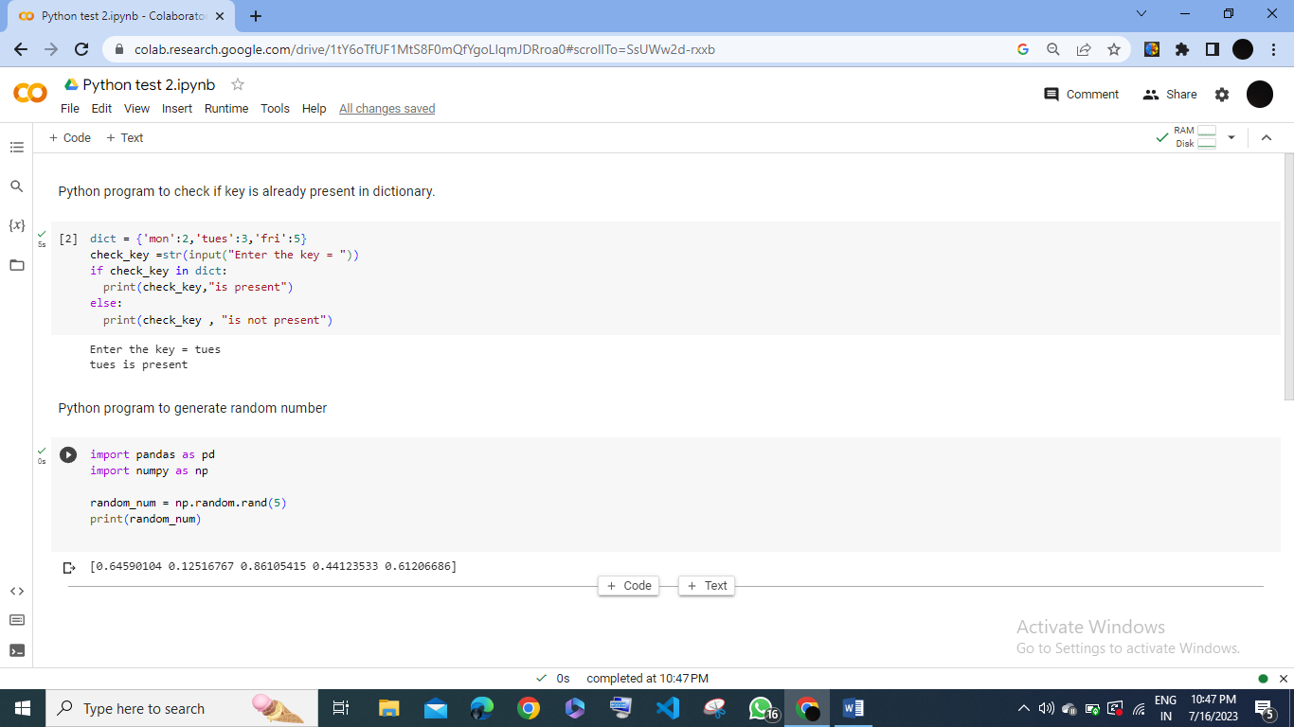

**3. flattend the list**

list = [[1,2,3],[3,4],[5,6,7]]

flat_list = []

for sublist in list:

flat_list.extend(element)

print(flat_list)

output:

[‘1’,’2’,’3’,’4’,’5’,’6’,’7’]

.